CPE477/ECG677
Embedded Security and Machine Learning
Design Assignment 2
Decision Tree Model Comparison for Activity Recognition
DO NOT REMOVE THIS PAGE DURING SUBMISSION:
Name: Carlos Funes
Group-Partner Name: _Jabril O. Smith
Email: funesc2@unlv.nevada.edu
Github Repository link (root): https://github.com/CaFu0320/senna/tree/main/DA2%20ECG677
Youtube Playlist link (root): https://youtube.com/playlist?list=PLLIny5qXi1AM&si=9r4MMgPdy5MrUBvA
Follow the submission guideline to be awarded points for this Assignment.
Submit the following for all Assignments:
1. In the document, for each task submit the modified or included code (from the base code) with highlights and justifications of the modifications. Also include the comments. If no base code is provided, submit the base code for the first task only.
2. Create a private Github repository with a random name (no CPE477/677, Lastname, Firstname). Place all assignments under the root folder, sub-folder named Assignmentn, with one document and one video link file for each lab, place modified c files named as main.c.
3. If multiple ‘c’ or ‘h’ files or other libraries are used, place these files inside the folder.
4. The folder should have a) Word document (see template), b) source code file(s) with other ‘c’ and ‘h’ include files, c) text file with youtube video links (see template).
5. Submit the pdf file in canvas before the due date. The root folder of the github assignment directory should have the documentation and the text file with youtube video links.
6. Organize your youtube videos as playlist under the name “EMBSEC&ML”. The playlist should have the video sequence arranged as submission or due dates.
7. Only submit pdf documents. Do not forget to upload this document in the github repository and in the canvas submission portal.
Declaration
I understand the Student Academic Misconduct Policy -
http://studentconduct.unlv.edu/misconduct/policy.html
“This assignment submission is my own, original work”.
Name of the Student: Carlos Funes

Decision Tree Activity Recognition

1 Abstract
This assignment developed four decision-tree classifiers for Static, Horizontal, and Vertical activity recognition using an LSM6DSV16X IMU and a NUCLEO-F401RE with an X-NUCLEO-IKS4A1 expansion board. Python pipelines prepared the recordings, trained raw and quaternion models with and without window statistics, selected quaternion features with ANOVA and recursive feature elimination, and exported JSON and C implementations. On the chronological test portions, RAW achieved 99.36% accuracy, RAW+FE 100.00%, QUAT 75.48%, and QUAT+FE 80.49%. A motion-statistics analysis informed a separate LSM6DSO16IS implementation combining Madgwick fusion and a QUAT+FE tree on the ISPU. That deployment model achieved 96.15% offline accuracy on 78 test windows, matched its Python reference on 463 C checks, and produced live activity outputs through the STM32 and MEMS Studio.

2 Schematics
The expansion board plugs into the Nucleo Arduino UNO R3 headers. The STM32 reads the selected IMU over I2C1 and communicates with MEMS Studio through USART2 and the ST-LINK virtual COM port. The two sensor targets share the physical board stack. [1, 2]
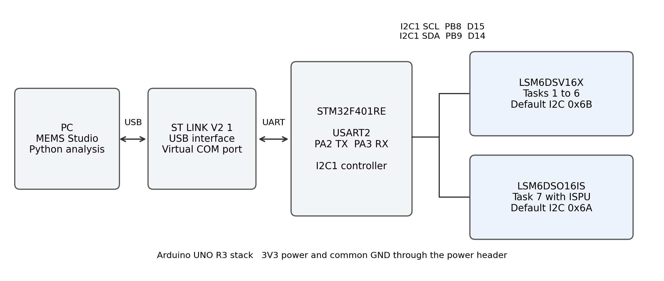
Figure 1. Hardware connections and sensor targets used across the assignment. Addresses are the board defaults documented by ST. [1, 2]
Table 1. Signals used by the hardware setup
Connection | Pin or interface | Function
I2C1 clock | PB8 / Arduino D15 | STM32 to shield SCL
I2C1 data | PB9 / Arduino D14 | Bidirectional sensor data
USART2 | PA2 TX and PA3 RX | ST-LINK virtual COM port
Power and reference | 3V3 and GND header pins | Shield power and common ground
USB | PC to ST-LINK mini-B connector | Board supply and host data link

3 Task Results
Task 1 Data Preparation and Exploratory Analysis
Recordings and preprocessing
The LSM6DSV16X recordings contain three acceleration axes, three angular-rate axes, four quaternion columns, and timestamps. Static means the board resting on a flat surface; Horizontal is repeated sideways motion; Vertical is repeated up-and-down motion. MEMS Studio 2.4.1 provided the data acquisition interface. The logs contain 6,273 rows before trimming.
Table 2. Dataset before and after removing 2 seconds at each edge
Activity | Raw rows | Retained rows | Retained duration s | Share percent
Horizontal | 2,100 | 1,814 | 25.4 | 33.5
Static | 2,038 | 1,756 | 25.4 | 32.4
Vertical | 2,135 | 1,842 | 25.1 | 34.0
Total | 6,273 | 5,412 | 75.9 | 100.0

The preparation script detects the logged columns, labels each recording from its filename, converts acceleration from mg to g and angular rate from mdps to dps, and expresses time in seconds. The first and last 2 seconds are removed for exploratory analysis. The checks found no entirely zero channels, repeated timestamps, or invalid quaternion norms; norms were approximately 0.999 to 1.001. Quaternion columns retain the order in the recorded files.
The retained rows are divided with a reproducible, class-stratified random 70/15/15 split using random_state = 42. This split documents the Task 1 preparation output. Tasks 2–6 use chronological portions of the untrimmed recordings, as specified in their model protocol.
Table 3. Task 1 stratified split sample counts
Class | Train | Val | Test | Total | Train % | Val % | Test %
hmotion | 1270 | 272 | 272 | 1814 | 70.0 | 15.0 | 15.0
static | 1229 | 263 | 264 | 1756 | 70.0 | 15.0 | 15.0
vmotion | 1289 | 277 | 276 | 1842 | 70.0 | 15.0 | 15.0
ALL | 3788 | 812 | 812 | 5412 | 70.0 | 15.0 | 15.0

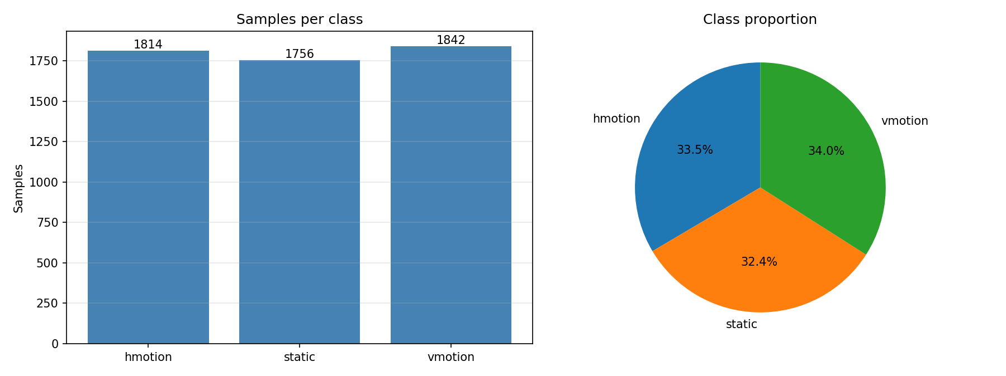
Figure 2. Balanced class distribution after trimming. HMotion and VMotion denote Horizontal and Vertical.
Task 1 Signal Behavior
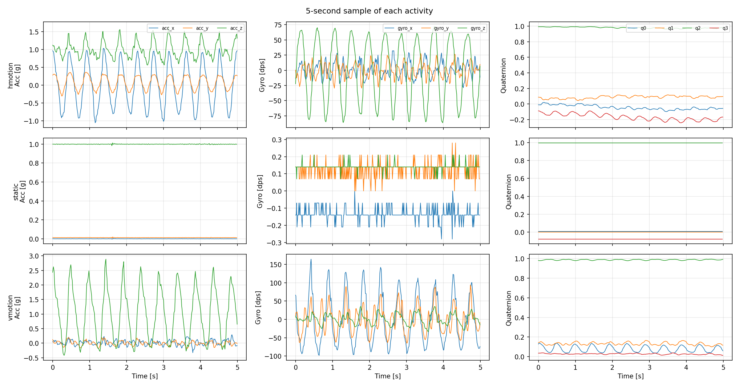
Figure 3. Five-second excerpts showing acceleration, angular rate, and the recorded quaternion components for each activity.
Static acceleration stays near gravity on the z axis, and angular rates remain close to zero. Horizontal motion produces its largest acceleration swing on x, with a strong z angular-rate oscillation. Vertical motion concentrates its acceleration swing on z and produces larger x and y angular rates. The moving classes repeat at roughly two cycles per second.
The quaternion components also have class-specific offsets. For example, mean q1 is approximately 0.000 for Static, 0.064 for Horizontal, and 0.134 for Vertical. These orientation levels explain part of the separability within the recordings and motivate the later checks of temporal drift.
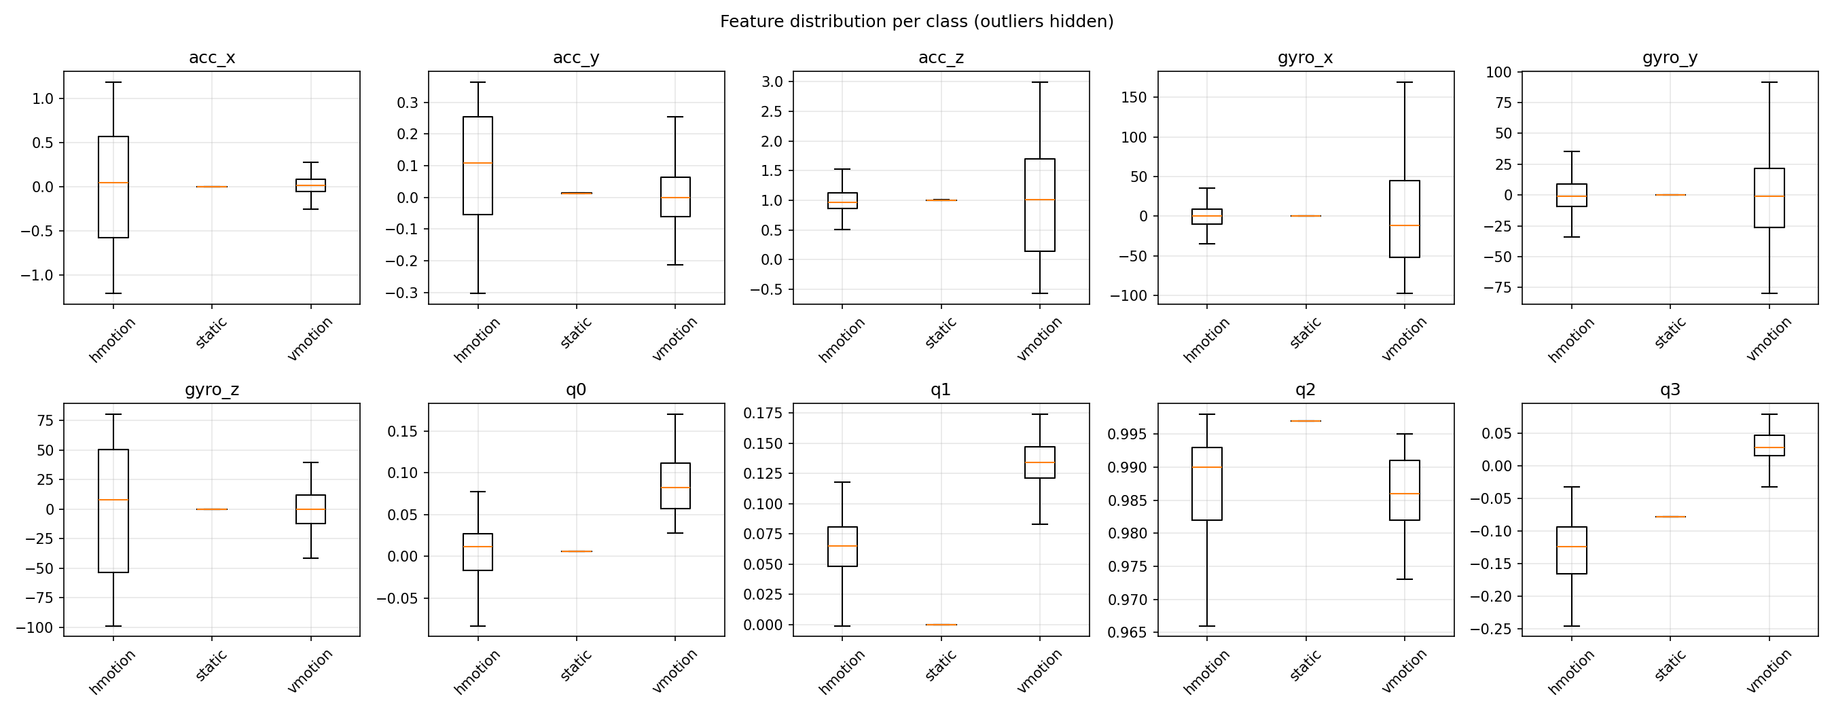
Figure 4. Per-class feature distributions. Acceleration is in g, angular rate in dps, and quaternion components are unitless.
Task 1 Per Class Statistics
The table summarizes the retained samples. The standard deviation describes the spread within each activity; quaternion statistics use the column labels from the data files.
Table 4. Feature statistics after trimming
Feature | Class | Mean | Std | Min | Max
acc_x | static | 0.000 | 0.001 | -0.009 | 0.012
acc_x | hmotion | 0.014 | 0.633 | -1.211 | 1.186
acc_x | vmotion | 0.016 | 0.095 | -0.328 | 0.304
acc_y | static | 0.013 | 0.001 | -0.004 | 0.025
acc_y | hmotion | 0.091 | 0.168 | -0.304 | 0.364
acc_y | vmotion | 0.006 | 0.093 | -0.214 | 0.373
acc_z | static | 0.999 | 0.004 | 0.960 | 1.041
acc_z | hmotion | 0.998 | 0.205 | 0.503 | 1.643
acc_z | vmotion | 1.000 | 0.870 | -0.575 | 2.994
gyro_x | static | -0.138 | 0.084 | -1.190 | 0.210
gyro_x | hmotion | -0.113 | 13.062 | -34.860 | 44.450
gyro_x | vmotion | -0.538 | 62.006 | -97.860 | 169.260
gyro_y | static | 0.123 | 0.068 | -0.490 | 0.840
gyro_y | hmotion | 0.191 | 13.542 | -43.680 | 51.030
gyro_y | vmotion | -0.115 | 33.817 | -80.010 | 99.470
gyro_z | static | 0.140 | 0.021 | 0.000 | 0.420
gyro_z | hmotion | -0.222 | 53.338 | -98.630 | 80.360
gyro_z | vmotion | 0.045 | 15.767 | -41.440 | 39.550
q0 | static | 0.006 | 0.000 | 0.006 | 0.007
q0 | hmotion | 0.002 | 0.039 | -0.097 | 0.077
q0 | vmotion | 0.084 | 0.032 | 0.028 | 0.170
q1 | static | -0.000 | 0.000 | -0.001 | 0.001
q1 | hmotion | 0.064 | 0.027 | -0.025 | 0.118
q1 | vmotion | 0.134 | 0.017 | 0.083 | 0.174
q2 | static | 0.997 | 0.000 | 0.997 | 0.997
q2 | hmotion | 0.987 | 0.009 | 0.960 | 0.998
q2 | vmotion | 0.986 | 0.005 | 0.973 | 0.995
q3 | static | -0.078 | 0.000 | -0.078 | -0.078
q3 | hmotion | -0.131 | 0.048 | -0.245 | -0.032
q3 | vmotion | 0.029 | 0.020 | -0.032 | 0.079

The strongest motion separation is in acc_x, acc_z, gyro_x, and gyro_z. Static accelerometer standard deviations are at most about 0.004 g; its angular-rate standard deviations are below 0.09 dps.
Task 1 Sampling and Temporal Dynamics
Timestamps are on a 10 ms grid, with some 20 ms gaps. The measured export rates are approximately 69–73 samples per second. Timing analysis uses the timestamps; only the spectral analysis interpolates onto a uniform 100 Hz grid. The classifier data remain the recorded samples.
Table 5. Measured timestamp spacing and export rates
Class | Samples | Duration [s] | Rate [Hz] | Step min / max [ms] | Steps of 20 ms [%]
hmotion | 1814 | 25.4 | 71.4 | 10 / 20 | 40
static | 1756 | 25.4 | 69.0 | 10 / 20 | 45
vmotion | 1842 | 25.1 | 73.3 | 10 / 20 | 36

Table 6. Feature ranges over the retained dataset
Feature | Unit | Min | Max | Mean | Std
acc_x | g | -1.211 | 1.186 | 0.010 | 0.371
acc_y | g | -0.304 | 0.373 | 0.037 | 0.118
acc_z | g | -0.575 | 2.994 | 0.999 | 0.521
gyro_x | dps | -97.860 | 169.260 | -0.266 | 36.950
gyro_y | dps | -80.010 | 99.470 | 0.065 | 21.226
gyro_z | dps | -98.630 | 80.360 | -0.014 | 32.215
q0 | - | -0.097 | 0.170 | 0.031 | 0.048
q1 | - | -0.025 | 0.174 | 0.067 | 0.058
q2 | - | 0.960 | 0.998 | 0.990 | 0.007
q3 | - | -0.245 | 0.079 | -0.059 | 0.074

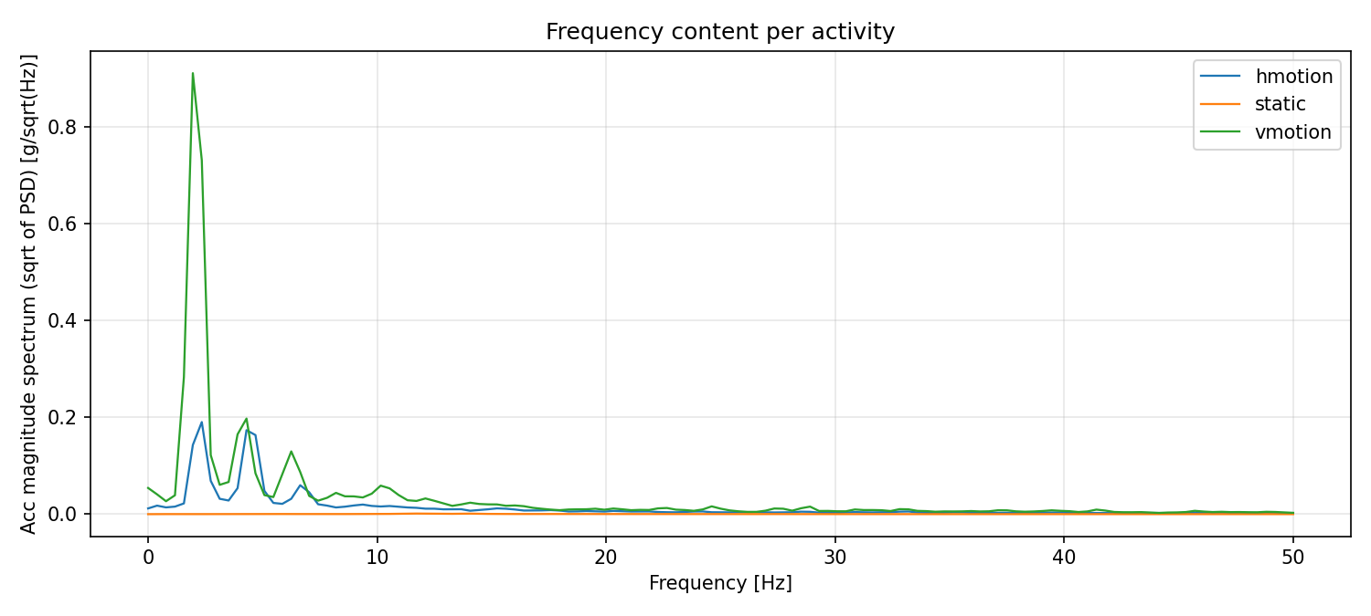
Figure 5. Acceleration-magnitude spectra from timestamp-based interpolation and Welch analysis.
The acceleration-magnitude peaks are 2.34 Hz for Horizontal and 1.95 Hz for Vertical. Both gyroscope-magnitude spectra peak near 4.30 Hz because taking magnitude creates two positive excursions per motion cycle. The small Static spectral peaks describe sensor noise rather than a repeated activity.
Task 2 RAW Model
Protocol and model configuration
The RAW classifier uses one sample of ACC_X, ACC_Y, ACC_Z, GYR_X, GYR_Y, and GYR_Z. The model and exported C function use the original log units, mg and mdps. Each untrimmed recording is cut into the first 70% for training, the next 15% for validation, and the remaining 15% for testing. The four-model comparison in Tasks 2–6 follows this protocol.
Table 7. Chronological sample counts used by the sample models
Class | Train | Validation | Test | Total
Horizontal | 1470 | 315 | 315 | 2100
Static | 1426 | 306 | 306 | 2038
Vertical | 1494 | 320 | 321 | 2135
All | 4390 | 941 | 942 | 6273

Table 8. Common decision-tree hyperparameters for Tasks 2–5
Parameter | Setting
criterion | gini
max_depth | None
min_samples_leaf / min_samples_split | 1 / 2
random_state | 42

Evaluation
Table 9. RAW test classification metrics
Class | Precision | Recall | F1-score | Support
Horizontal | 0.9905 | 0.9968 | 0.9937 | 315
Static | 0.9935 | 1.0000 | 0.9967 | 306
Vertical | 0.9968 | 0.9844 | 0.9906 | 321
macro avg | 0.9936 | 0.9937 | 0.9937 | 942
weighted avg | 0.9937 | 0.9936 | 0.9936 | 942

Table 10. RAW accuracy across the three portions
Partition | Correct / total | Accuracy percent
Training | 4,390 / 4,390 | 100.00
Validation | 938 / 941 | 99.68
Test | 936 / 942 | 99.36

The train–test gap is 0.64 percentage points. The model correctly recognizes all 306 Static test samples. Six errors remain among the moving activities, where an individual sample can resemble a turning point or a brief low-motion interval from another class.
Task 2 Errors and Tree Structure
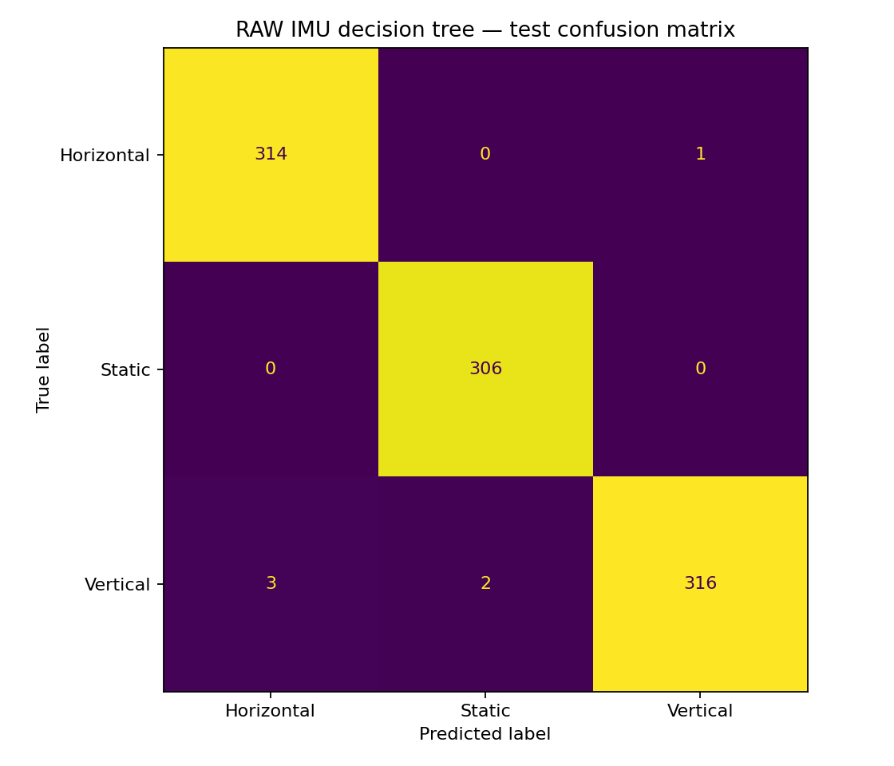
Figure 6. RAW test confusion matrix. Rows are true activities and columns are predictions.
The errors are one Horizontal sample predicted as Vertical, three Vertical samples predicted as Horizontal, and two Vertical samples predicted as Static. Their instantaneous sensor values overlap the regions assigned to the other classes. Window statistics in Task 3 summarize more of the repeated motion than these single values.
Table 11. RAW model complexity and timing interpretation
Tree metric | Result
Depth / leaves / nodes | 10 / 48 / 95
Serialized JSON | 43.679 KB
Illustrative packed tree storage | 855 B at 9 B per node
PC exported-tree traversal | 1.671 µs per sample
Analytical MCU tree estimate | 1.43 µs at 84 MHz, 12 cycles per level

PC timings and the cycle model describe tree traversal. The MCU value is an analytical estimate with the stated assumptions.
Task 2 Feature Importance and Export
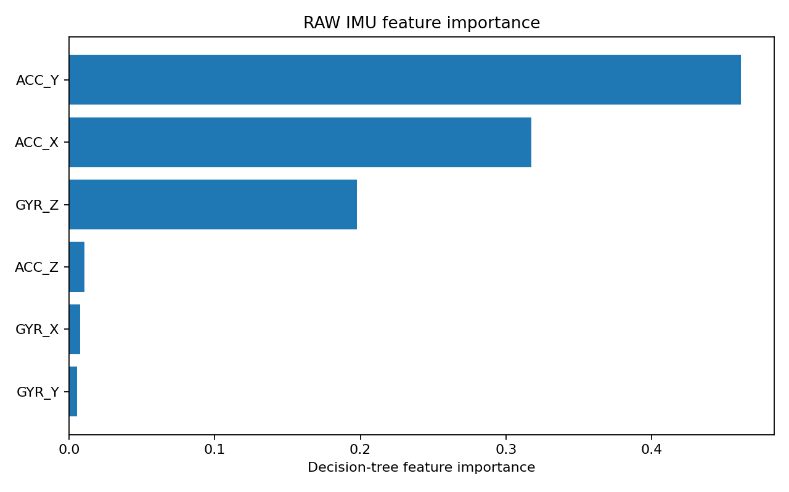
Figure 7. Gini importance of the six RAW inputs.
ACC_Y contributes 46.10% of the Gini importance, ACC_X 31.73%, and GYR_Z 19.77%. The remaining three axes contribute about 2.4% combined. ACC_Y separates small resting offsets in these recordings, while x acceleration and z rotation describe the sideways activity. This ranking is specific to the recorded placement and motion.
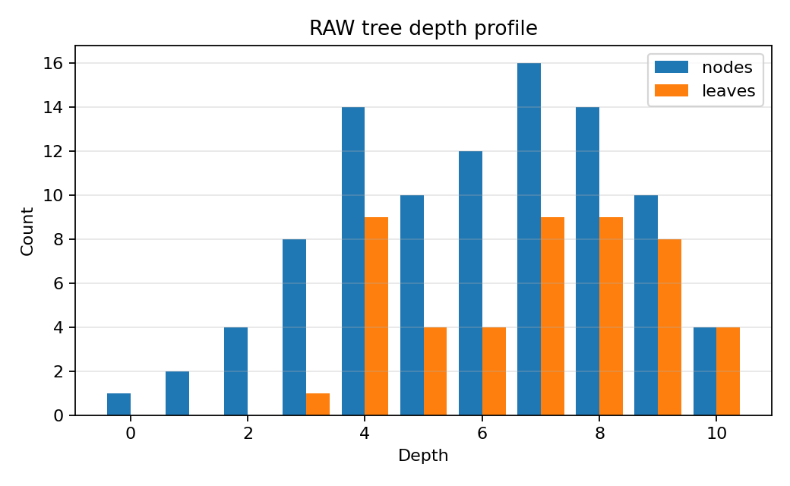
Figure 8. RAW tree depth profile, showing the distribution of nodes and leaves.
The complete 95-node structure is exported as decision_tree_raw.json, together with decision_tree_raw.c and .h. Node records preserve feature indices, thresholds, child links, and predicted classes. The generated C model reproduced the Python predictions on all 6,273 checked samples.
Task 3 RAW Plus Feature Engineering
Windowing and feature definitions
Task 3 replaces one sensor sample with statistics from a 42-sample window. Consecutive windows use a 21-sample stride, so overlap is 50%. At the measured mean logging rate of about 71.3 Hz, buffer fill is approximately 0.59 seconds and subsequent windows advance approximately every 0.29 seconds. Windows are created inside the chronological partitions, preserving their separation.
Table 12. Six statistics extracted for each sensor axis
Statistic | Definition
Mean | Arithmetic average
Variance | Population variance using division by n
Maximum and minimum | Largest and smallest value in the window
Peak-to-peak | Maximum minus minimum
Energy | Mean squared value

Six axes multiplied by six statistics yield 36 input features. The classifier uses all 36 candidate features and the same tree hyperparameters as Task 2. A 42 × 6 float32 window occupies 1,008 bytes.
Table 13. Window counts after partitioning each recording
Class | Train | Validation | Test | Total
Horizontal | 69 | 14 | 14 | 97
Static | 66 | 13 | 13 | 92
Vertical | 70 | 14 | 14 | 98
All | 205 | 41 | 41 | 287

Table 14. RAW+FE test classification metrics
Class | Precision | Recall | F1-score | Support
Horizontal | 1.0000 | 1.0000 | 1.0000 | 14
Static | 1.0000 | 1.0000 | 1.0000 | 13
Vertical | 1.0000 | 1.0000 | 1.0000 | 14
macro avg | 1.0000 | 1.0000 | 1.0000 | 41
weighted avg | 1.0000 | 1.0000 | 1.0000 | 41

Training, validation, and test accuracies are each 100.00%. The test result is 41 correct windows out of 41, including 14 Horizontal, 13 Static, and 14 Vertical. The evaluation unit is a window; the RAW result is evaluated per sample.
Task 3 Classification Results and Complexity
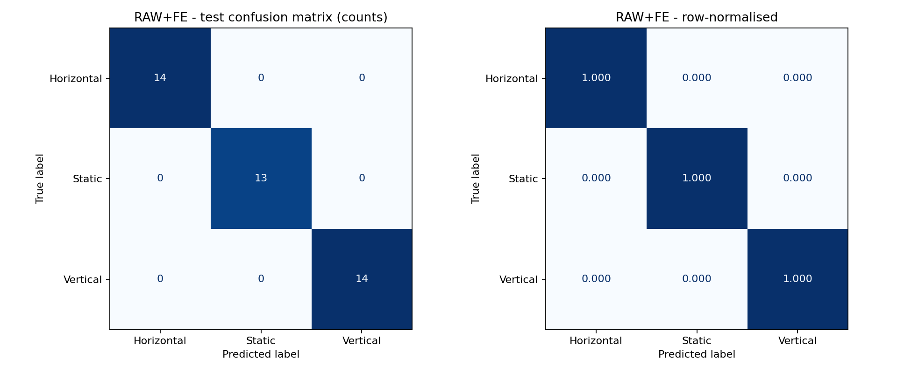
Figure 9. RAW+FE test confusion matrix with counts and row-normalized proportions.
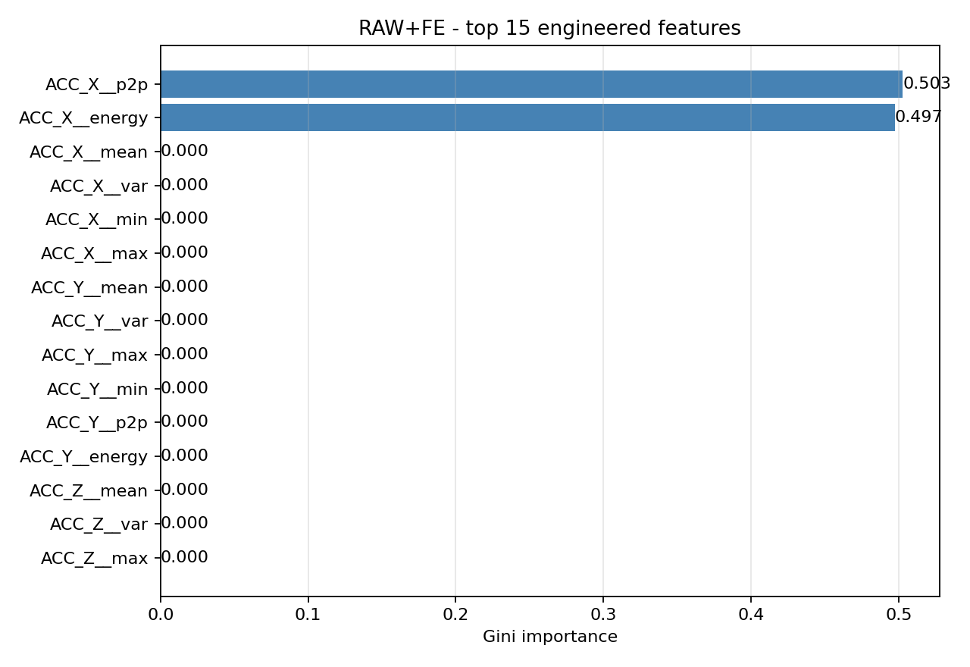
Figure 10. Engineered feature importance. Only two of the 36 inputs are used by the fitted tree.
ACC_X__p2p contributes 50.27% of the importance and ACC_X__energy 49.73%. The resulting rule first separates Horizontal when x-axis peak-to-peak exceeds 1,128 mg. Otherwise, an x-axis energy threshold of approximately 1,707 mg² separates Static from Vertical. Several other window statistics also distinguish the activities, so a zero importance here indicates that the tree selected another available split.
Table 15. Feature engineering reduces the tree while adding window storage
Metric | RAW | RAW+FE
Depth / leaves / nodes | 10 / 48 / 95 | 2 / 3 / 5
JSON size KB | 43.679 | 4.837
Packed tree estimate B | 855 | 45
Window RAM B | 0 | 1,008
Analytical tree time µs | 1.43 | 0.29

The C window-feature implementation and exported tree agreed with Python on 881 checked windows. The 41-window test describes the recorded motions; adjacent windows overlap within their own partition.
Task 4 Quaternion Model
Features and evaluation
The QUAT classifier receives the four recorded components q0, q1, q2, and q3 of one sample. It uses the chronological partitions and tree hyperparameters of Task 2. Training and validation each reach 100.00%; the test result is 711 correct predictions out of 942, or 75.48%. The train–test gap is 24.52 percentage points.
Table 16. QUAT test classification metrics
Class | Precision | Recall | F1-score | Support
Horizontal | 0.5769 | 1.0000 | 0.7317 | 315
Static | 1.0000 | 1.0000 | 1.0000 | 306
Vertical | 1.0000 | 0.2804 | 0.4380 | 321
macro avg | 0.8590 | 0.7601 | 0.7232 | 942

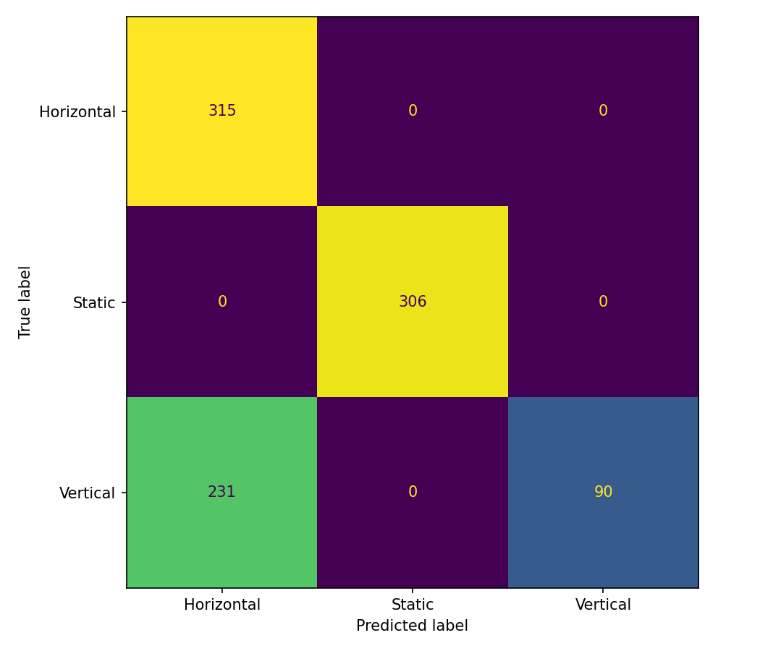
Figure 11. QUAT test confusion matrix. All 231 errors are Vertical samples predicted as Horizontal.
The model uses q3 and q2. Its first rule assigns Vertical when q3 exceeds approximately −0.0015. The mean Vertical q3 moves from +0.038 in the training portion to −0.015 in the test portion. Consequently, many later Vertical samples cross into the region labeled Horizontal. The absolute orientation of the board explains the rule more directly than the repeated vertical motion.
Task 4 Compactness and Orientation Effects
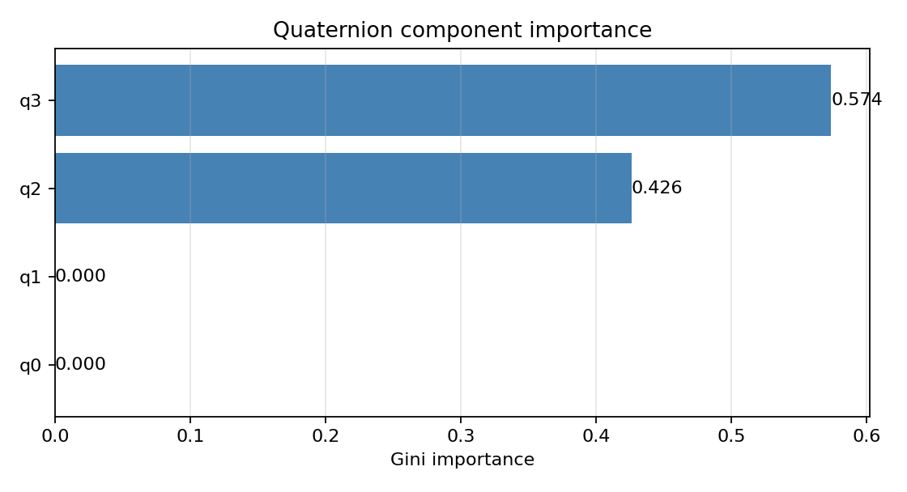
Figure 12. Quaternion component importance: q3 supplies 57.39% and q2 42.61%.
Table 17. Mean quaternion components in the training and test portions
Recording | Block | q0 | q1 | q2 | q3
Horizontal | train / test | 0.003 / 0.015 | 0.061 / 0.067 | 0.986 / 0.991 | −0.131 / −0.105
Static | train / test | 0.006 / 0.006 | 0.000 / 0.000 | 0.997 / 0.997 | −0.078 / −0.078
Vertical | train / test | 0.081 / 0.074 | 0.133 / 0.115 | 0.986 / 0.990 | +0.038 / −0.015

Table 18. QUAT produces a compact sample classifier
Metric | RAW | QUAT
Input features | 6 | 4
Depth / leaves / nodes | 10 / 48 / 95 | 3 / 4 / 7
JSON size KB | 43.679 | approximately 3.2
Packed tree estimate B | 855 | 63
Analytical tree time µs | 1.43 | 0.43
Test accuracy percent | 99.36 | 75.48

The smaller tree uses less model storage, while quaternion generation is an additional processing stage. Its C export matched the Python decisions on all 6,273 checked samples. The observed drift makes absolute quaternion thresholds sensitive to the time portion used for evaluation.
Additional checks in the original analysis held out each of five time blocks in turn. QUAT averaged 94.18% accuracy, with a worst fold of 81.59%. A second set of quaternion-only logs gave 100.00% chronological test accuracy, but transfer between the two datasets was approximately 34%. These checks support using temporal behavior of the quaternion when developing a motion classifier.
Task 5 Quaternion Feature Engineering and Selection
Feature extraction and selection
A 42-sample window and 21-sample stride produce 24 candidates: six statistics for each of four quaternion components. ANOVA F-statistics are calculated on the training windows to describe class separation. Recursive feature elimination uses a 200-tree random forest with seed 42 to rank all candidates, then retains the top eight. A separate decision tree with the Task 2 settings is fitted to these eight inputs.
The random forest distributes split importance across several correlated candidates. This gives the recursive elimination process more information than a single training tree that reaches purity using only one or two features. All selection uses the training portion.
Table 19. ANOVA scores and RFE ranks for all 24 quaternion candidates
# | Feature | F | p-value | RFE rank | Selected
1 | q3__p2p | 2959 | <0.001 | 3 | yes
2 | q3__var | 2020 | <0.001 | 1 | yes
3 | q1__max | 936 | <0.001 | 4 | yes
4 | q0__p2p | 862 | <0.001 | 13 | no
5 | q1__energy | 693 | <0.001 | 5 | yes
6 | q3__min | 665 | <0.001 | 2 | yes
7 | q1__mean | 622 | <0.001 | 16 | no
8 | q3__mean | 517 | <0.001 | 6 | yes
9 | q1__p2p | 510 | <0.001 | 14 | no
10 | q1__min | 418 | <0.001 | 18 | no
11 | q3__max | 415 | <0.001 | 7 | yes
12 | q0__var | 403 | <0.001 | 11 | no
13 | q2__p2p | 335 | <0.001 | 12 | no
14 | q0__max | 328 | <0.001 | 20 | no
15 | q0__energy | 233 | <0.001 | 19 | no
16 | q0__mean | 159 | <0.001 | 24 | no
17 | q2__min | 143 | <0.001 | 10 | no
18 | q2__var | 129 | <0.001 | 9 | no
19 | q1__var | 101 | <0.001 | 8 | yes
20 | q3__energy | 99 | <0.001 | 21 | no
21 | q2__energy | 95 | <0.001 | 15 | no
22 | q2__mean | 94 | <0.001 | 17 | no
23 | q0__min | 77 | <0.001 | 22 | no
24 | q2__max | 48 | <0.001 | 23 | no

Selected features, in RFE order: q3__var, q3__min, q3__p2p, q1__max, q1__energy, q3__mean, q3__max, q1__var. The reported p-values describe training-window separation; neighboring windows overlap.
Task 5 Selected Features and Test Results
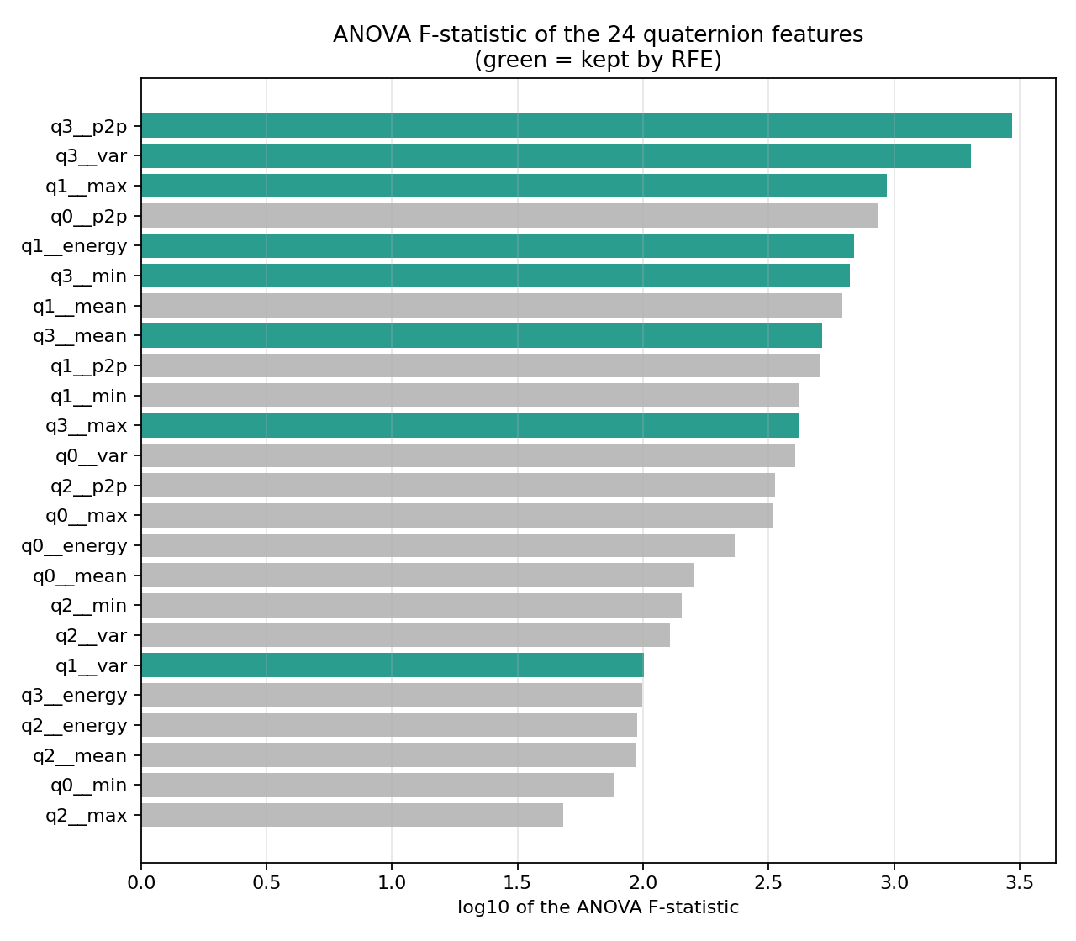
Figure 13. ANOVA F-statistics on a logarithmic scale. Green bars denote the eight features retained by RFE.
Selection retains five q3 statistics and three q1 statistics. All q0 and q2 candidates, together with q1 mean, minimum, and peak-to-peak and q3 energy, are eliminated. Some high-scoring univariate features are removed because RFE judges their joint contribution to the forest. Correlated features can remain: q3 variance and peak-to-peak have approximately 0.98 correlation in the training analysis.
Table 20. QUAT+FE test classification metrics
Class | Precision | Recall | F1-score | Support
Horizontal | 0.6364 | 1.0000 | 0.7778 | 14
Static | 1.0000 | 1.0000 | 1.0000 | 13
Vertical | 1.0000 | 0.4286 | 0.6000 | 14
macro avg | 0.8788 | 0.8095 | 0.7926 | 41

Table 21. QUAT+FE accuracy with eight selected inputs
Partition | Windows | Accuracy percent
Training | 205 | 100.00
Validation | 41 | 100.00
Test | 41 | 80.49

The test result is 33 / 41 correct windows; the train–test gap is 19.51 percentage points.
Task 5 Motion Statistics and Orientation Levels
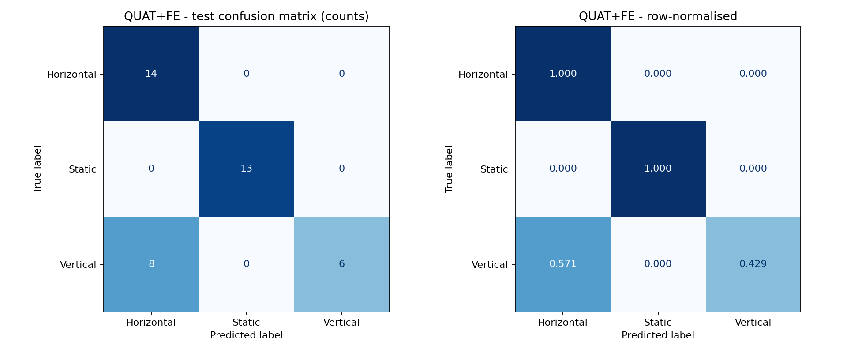
Figure 14. QUAT+FE test confusion matrix. Eight Vertical windows are classified as Horizontal.
The final tree uses q3__max with 50.62% importance and q1__energy with 49.38%. The root assigns Vertical when q3__max exceeds about 0.0025. The median q3 maximum in Vertical windows falls from 0.049 in training to −0.008 in testing, producing the same orientation sensitivity observed in Task 4.
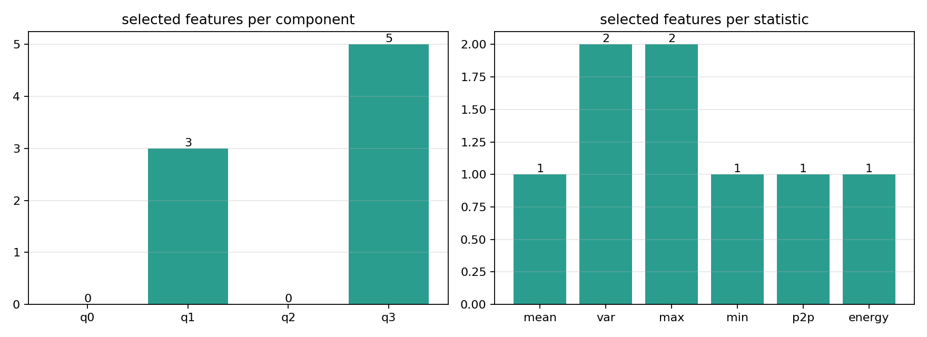
Figure 15. Distribution of the eight selected inputs across quaternion components and statistics.
Table 22. Feature-group checks using the original recordings
Quaternion feature group | Test accuracy percent | Five-block mean percent | Worst block percent
All 24 candidates | 80.49 | 90.71 | 53.57
Variance and peak-to-peak only | 100.00 | 96.07 | 80.36
Mean, max, min, energy only | 87.80 | 91.79 | 67.86

Restricting the candidates to variance and peak-to-peak improves the original chronological window test to 100.00%. Those statistics emphasize variation inside a window rather than its absolute orientation level. This result motivated the motion-statistics input set for Task 7.
The eight-feature Task 5 tree has depth 2, three leaves, five nodes, a 4.675 KB JSON file, and a 672 B quaternion window buffer. Its C export matched Python on 684 windows.
Task 6 Comprehensive Model Comparison
The four-model comparison uses the original LSM6DSV16X recordings, chronological partitions, and common hyperparameters. RAW and QUAT predict one class per sample; RAW+FE and QUAT+FE predict one class per window. Precision, recall, and F1 below are macro averages across the three classes.
Table 23. All four baseline model results
Metric | RAW | RAW+FE | QUAT | QUAT+FE
Tree input | 1 sample | 42 samples | 1 sample | 42 samples
Input features | 6 | 36 | 4 | 8 of 24
Test items | 942 samples | 41 windows | 942 samples | 41 windows
Train accuracy percent | 100.00 | 100.00 | 100.00 | 100.00
Validation accuracy percent | 99.68 | 100.00 | 100.00 | 100.00
Test accuracy percent | 99.36 | 100.00 | 75.48 | 80.49
Macro precision | 0.9936 | 1.0000 | 0.8590 | 0.8788
Macro recall | 0.9937 | 1.0000 | 0.7601 | 0.8095
Macro F1 | 0.9937 | 1.0000 | 0.7232 | 0.7926
Train minus test pp | 0.64 | 0.00 | 24.52 | 19.51
Depth | 10 | 2 | 3 | 2
Leaves / nodes | 48 / 95 | 3 / 5 | 4 / 7 | 3 / 5
JSON size KB | 43.679 | 4.837 | approximately 3.2 | 4.675
Packed tree estimate B | 855 | 45 | 63 | 45
Window RAM B | 0 | 1,008 | 0 | 672
Tree time estimate µs | 1.43 | 0.29 | 0.43 | 0.29

pp means percentage points. The illustrative storage model assumes 9 packed bytes per tree node. Window RAM assumes float32 samples. Tree time uses depth × 12 cycles / 84 MHz; feature extraction, fusion, memory padding, and communication are separate costs.
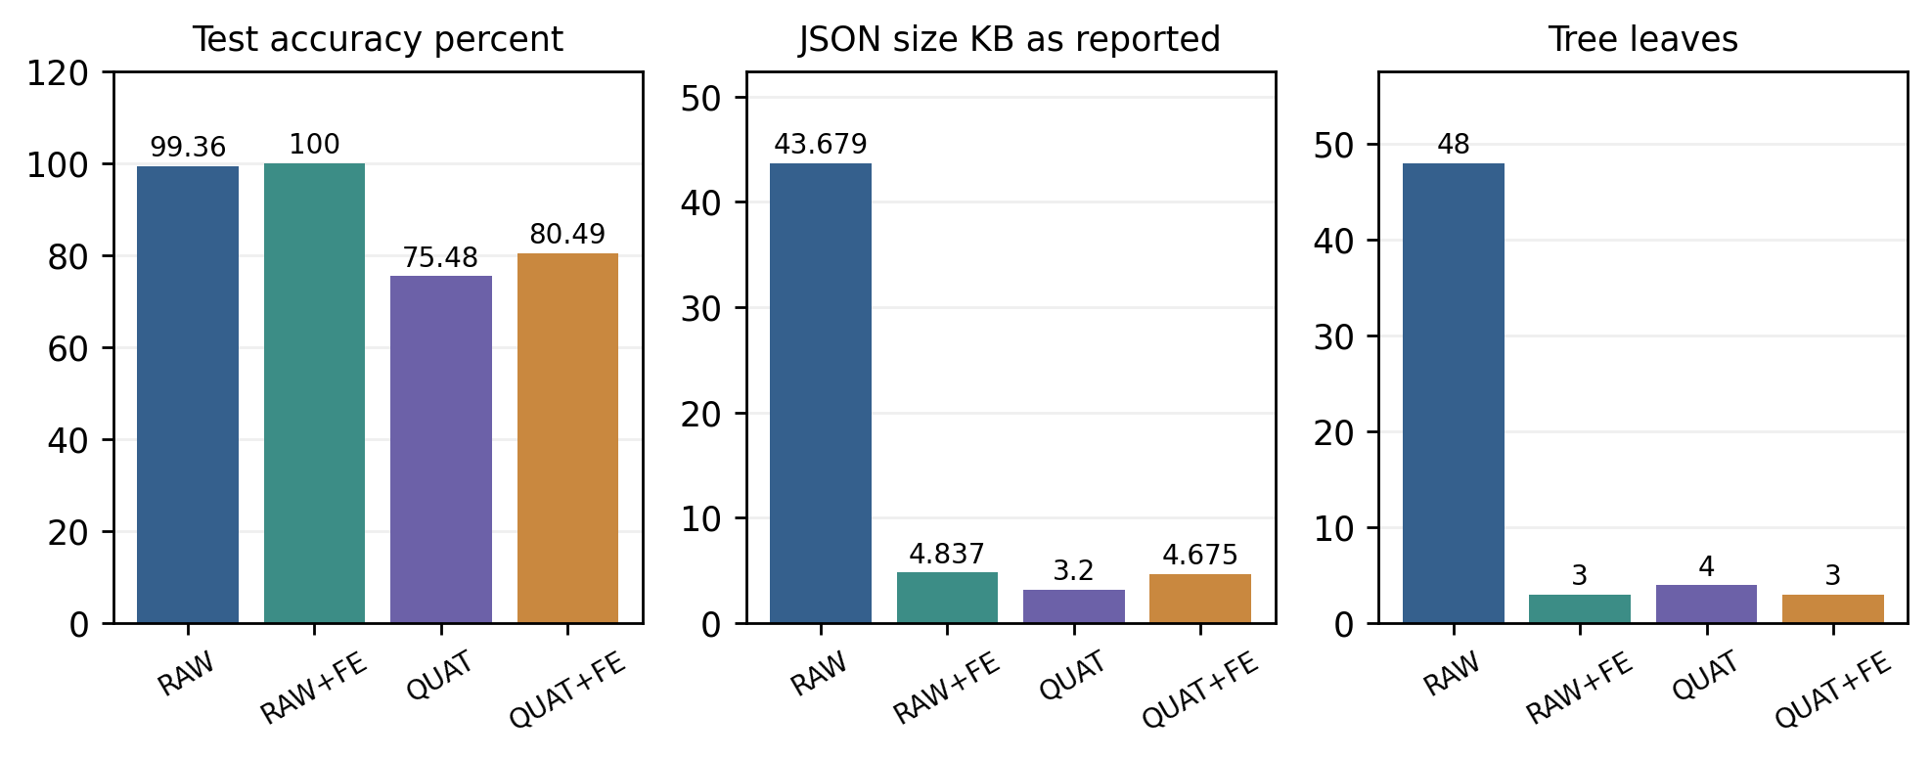
Figure 16. Model accuracy, serialized JSON size, and leaf count. Sample and window accuracies retain their respective evaluation units.
Task 6 Confusion Matrix Comparison
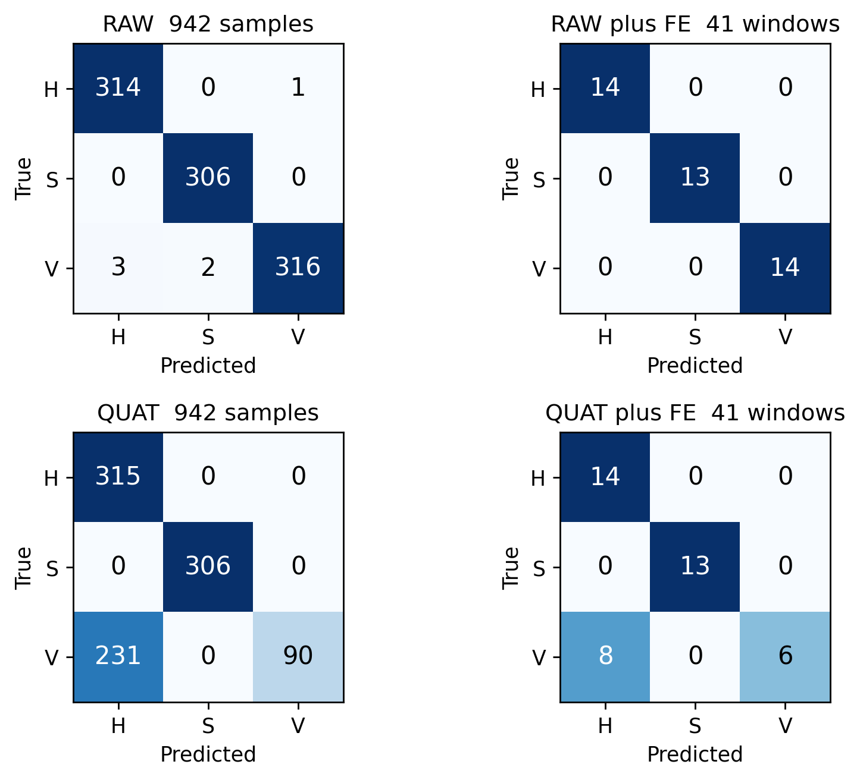
Figure 17. Side-by-side comparison in a two-by-two layout. H = Horizontal, S = Static, V = Vertical. Numbers are counts; color is recall normalized within each true class.
RAW+FE correctly classifies all 41 test windows. RAW makes six errors among 942 individual samples. The quaternion classifiers retain high Static recall but lose Vertical recall when the recording orientation changes: 0.2804 for QUAT and 0.4286 for QUAT+FE. Thus, the main difference among the baseline representations is the moving-class separation, especially Vertical versus Horizontal.
Table 24. Software verification of the generated C decision paths
C export | Reference items checked | Agreement
RAW | 6,273 samples | 100%
RAW+FE | 881 windows | 100%
QUAT | 6,273 samples | 100%
QUAT+FE | 684 windows | 100%

The C checks confirm matching decisions for the supplied inputs. Each export keeps the input order, split thresholds, and class labels used in its Python model. This preserves the behavior of the trained tree when it is converted into an embedded representation.
Task 6 Robustness Across Time Blocks
A five-block evaluation holds out one consecutive time block from every recording at a time. All four models use the same block protocol. QUAT+FE repeats selection using only the training blocks of each fold.
Table 25. Accuracy percent for each held-out time block
Model | Block 1 | Block 2 | Block 3 | Block 4 | Block 5 | Mean | Worst
RAW | 91.9 % | 99.8 % | 99.9 % | 99.8 % | 99.5 % | 98.2 % | 91.9 %
RAW+FE | 100.0 % | 100.0 % | 100.0 % | 100.0 % | 100.0 % | 100.0 % | 100.0 %
QUAT | 89.3 % | 100.0 % | 100.0 % | 100.0 % | 81.6 % | 94.2 % | 81.6 %
QUAT+FE | 57.1 % | 100.0 % | 100.0 % | 100.0 % | 100.0 % | 91.4 % | 57.1 %

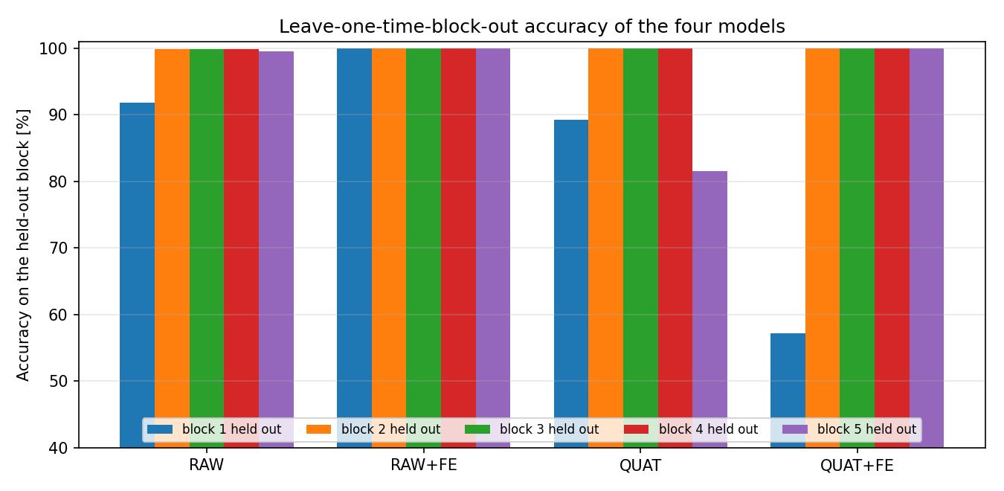
Figure 18. Block-wise accuracy from the original four-model comparison.
RAW+FE reaches 100.0% in all five folds. RAW averages 98.2% with a 91.9% worst block. QUAT and QUAT+FE show their largest losses near recording edges, consistent with changing orientation levels. These folds are time portions of the recorded activities; overlapping windows within each portion remain temporally related.
Table 26. Performance ranking by category
Ranking criterion | Best result in the baseline comparison
Chronological accuracy | RAW+FE at 100.00% on 41 windows
Fewest leaves | RAW+FE and QUAT+FE, three each
Smallest serialized model | QUAT, approximately 3.2 KB JSON
Smallest packed tree estimate | RAW+FE and QUAT+FE, 45 B each
Smallest train–test gap | RAW+FE, 0.00 percentage points
Best five-block result | RAW+FE, 100.0% in each fold

Task 6 Model Choice and Processing Cost
Table 27. Model selection decision matrix
Use case | Choice for these recordings | Reason
Highest recorded window accuracy | RAW+FE | 100% test and five-block accuracy with a five-node tree
Immediate sample decisions | RAW | No window buffering; 99.36% chronological test accuracy
Compact orientation classifier | QUAT | Four inputs and a seven-node tree; suited to a controlled orientation range
Quaternion-based motion processing | Variance and peak-to-peak features | Uses within-window changes and informed Task 7 deployment

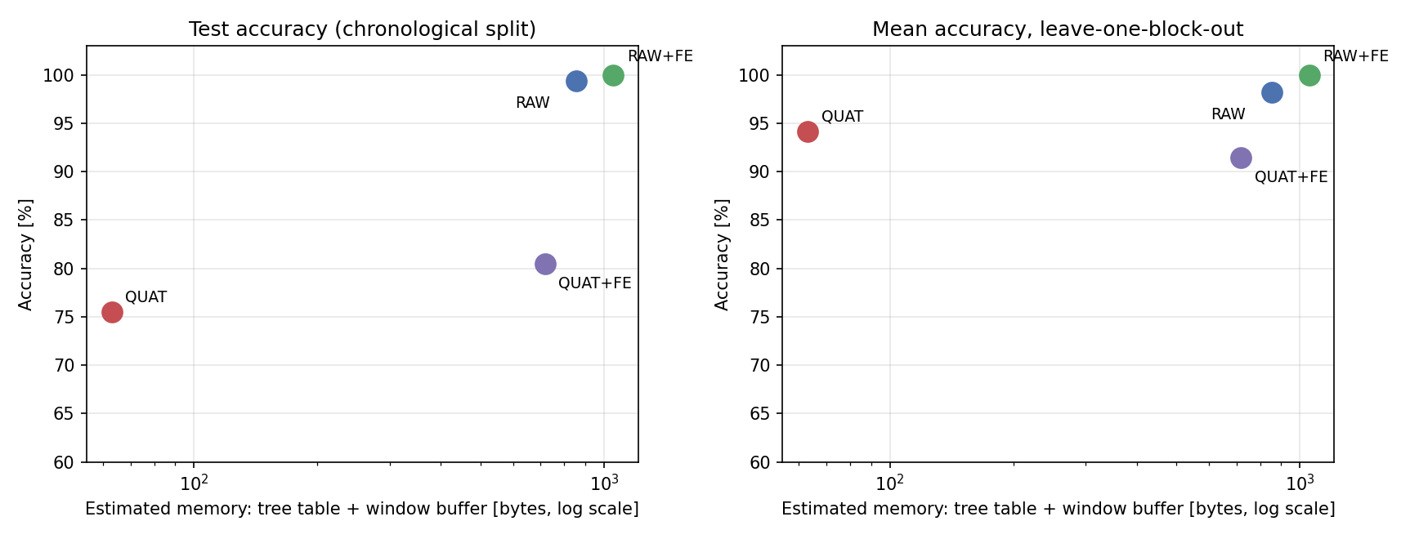
Figure 19. Accuracy versus the illustrative sum of packed tree storage and window-buffer storage. This storage total combines different memory roles.
Feature engineering reduces tree depth but adds a buffer and statistics. RAW+FE stores 42 × 6 float32 values, while QUAT+FE stores 42 × 4. The corresponding buffer sizes are 1,008 B and 672 B. For a tree with constant nodes, tree storage can be placed in program memory; the sample buffer occupies writable RAM.
Quaternion models also require orientation fusion before classification. Their cost therefore depends on whether fusion already serves another application. The original data favor RAW+FE for window recognition and RAW for frequent sample decisions. The motion-statistics result gives a practical route for the ISPU implementation rather than transferring the orientation-level thresholds unchanged.
Task 7 ISPU Implementation
Objective and hardware configuration
Task 7 implements a six-axis Madgwick orientation estimator and a QUAT+FE decision tree on the LSM6DSO16IS ISPU. The STM32F401RE retrieves the output registers and forwards quaternion components and activity IDs to MEMS Studio. The activity mapping is 0 = Horizontal, 1 = Static, and 2 = Vertical. [8, 9]
Table 28. ISPU and host operating configuration
Parameter | Implemented setting
Sensor and processing target | LSM6DSO16IS on-sensor ISPU
Host controller and expansion board | NUCLEO-F401RE with X-NUCLEO-IKS4A1
Accelerometer | ±8 g, high-performance mode, 208 Hz
Gyroscope | ±2000 dps, high-performance mode, 208 Hz
Madgwick update rate | 208 updates per second
Selected quaternion stream | 120 samples per second nominal
Measured host export | approximately 120.5 rows per second
Host readout | Timer-triggered polling of 64 ISPU DOUT bytes
Serial link | USART2, 921600 baud, 8-N-1

Processing sequence
The firmware first estimates gyro offsets during a stationary calibration interval. It then applies the custom Madgwick filter to acceleration and angular-rate samples, selects quaternion outputs for window processing, computes motion statistics, and traverses a compact C tree. The selected activity ID and quaternion values are published in the ISPU data-output register block.
Table 29. Implemented Task 7 processing stages
Stage | Operation
1 Acquisition | Read three acceleration and three angular-rate channels
2 Fusion | Apply stationary calibration and Madgwick orientation update
3 Sample selection | Select 120 quaternion samples per 208 native updates
4 Feature engineering | Calculate variance and peak-to-peak for q0–q3
5 Classification | Traverse the 17-node C decision tree
6 Host display | Poll DOUT registers and transmit the activity output

Task 7 Feature Window and Firmware Integration
The deployment model uses eight inputs: variance and peak-to-peak for each of q0, q1, q2, and q3. A 42-sample window advances by 21 samples, preserving 50% overlap. At the nominal selected rate of 120 Hz, the buffer-fill interval is approximately 0.350 s and the prediction stride is approximately 0.175 s.
Table 30. Deployment model and output format
Model item | Implemented value
Feature order | q0 var, q0 p2p, q1 var, q1 p2p, q2 var, q2 p2p, q3 var, q3 p2p
Window / stride | 42 / 21 quaternion samples
Nodes / leaves / maximum depth | 17 / 9 / 4
Class outputs | 0 Horizontal, 1 Static, 2 Vertical
Internal quaternion convention | q[0] = w; q[1], q[2], q[3] = x, y, z
Export order | x, y, z, w
Prediction fields | predicted_class and leaf_training_purity

Sample selection and prediction code
#define ISPU_HZ 208u
#define QUAT_OUTPUT_HZ 120u
resample_phase += QUAT_OUTPUT_HZ;
if (resample_phase < ISPU_HZ) return;
resample_phase -= ISPU_HZ;

float features[QUATFE_FEATURES];
quatfe_window_features(qwin, features);
QuatFePrediction p = quatfe_predict_features(features);
activity_id = p.predicted_class;

The phase accumulator selects samples from the 208 Hz processing sequence without interpolation. Fusion and exported samples therefore have distinct rates. The host timer reads the shared register output at approximately 120.5 Hz.
Output-register mapping
cast_float(ISPU_DOUT_00) = q[1]; /* x */
cast_float(ISPU_DOUT_02) = q[2]; /* y */
cast_float(ISPU_DOUT_04) = q[3]; /* z */
cast_float(ISPU_DOUT_06) = q[0]; /* w */
cast_uint32_t(ISPU_DOUT_20) = activity_id;

Source excerpts: ISPU_208hz/src/main.c, fusion_core.c, madgwick.c, and quat_fe_tree.c/.h, as documented in the Task 7 implementation report. Yellow marks identify the rate-selection, feature, prediction, and activity-output lines. [8]
Task 7 Model Development and Offline Evaluation
The deployment tree was retrained using new LSM6DSO16IS recordings of the same three activities. Chronological train, validation, and test portions were taken within each recording, with gaps between the portions. The C implementation and Python reference use the same selected quaternion statistics. [8, 9]
Table 31. Task 7 recordings used for model development
Activity | Output samples | Duration s | Measured export Hz
Horizontal | 3,655 | 30.321 | 120.51
Static | 3,653 | 30.312 | 120.48
Vertical | 3,659 | 30.361 | 120.48
Total | 10,967 | 90.994 | approximately 120.5

Table 32. Offline evaluation of the deployment tree
Partition | Correct / total windows | Accuracy percent
Training | 288 / 307 | 93.81
Validation | 75 / 78 | 96.15
Chronological test | 75 / 78 | 96.15

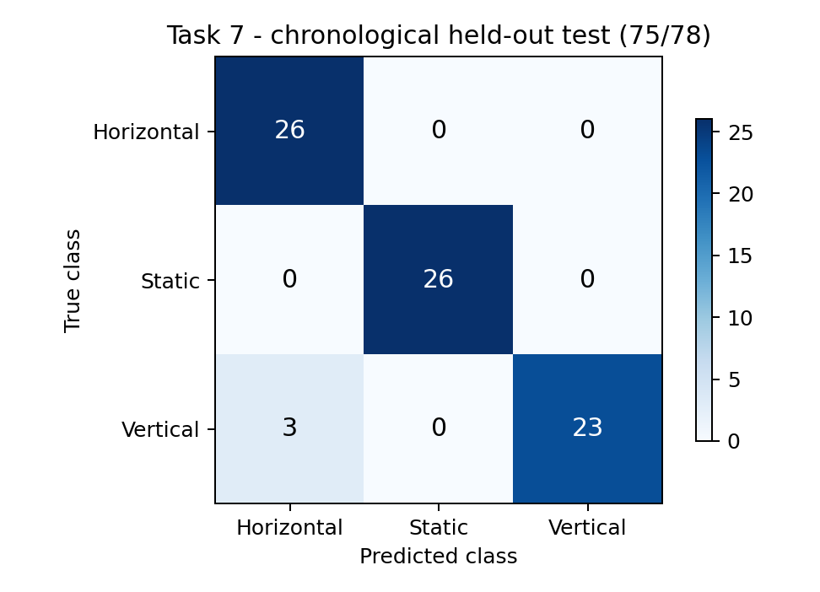
Figure 20. Deployment model confusion matrix on 78 chronological test windows. Rows are true activities and columns are predictions.
All 26 Horizontal and all 26 Static windows are classified correctly. Of 26 Vertical windows, 23 are correct and three are classified as Horizontal. The result describes held-out portions of the recorded sessions. Task 7 uses a new sensor stream and retrained model, so its accuracy is reported separately from the baseline comparison.
Task 7 Reference Agreement and Quaternion Output
Table 33. Task 7 metrics calculated from the test confusion matrix
Class | Precision | Recall | F1 | Support
Horizontal | 0.8966 | 1.0000 | 0.9455 | 26
Static | 1.0000 | 1.0000 | 1.0000 | 26
Vertical | 1.0000 | 0.8846 | 0.9388 | 26
Macro average | 0.9655 | 0.9615 | 0.9614 | 78

The host-side C feature calculation and tree produced the same decisions as the Python/JSON reference on all 463 checked windows, giving 100% offline agreement. This comparison checks the implementation for equivalent input windows. The 96.15% classification result measures the separate comparison against activity labels. [8, 9]
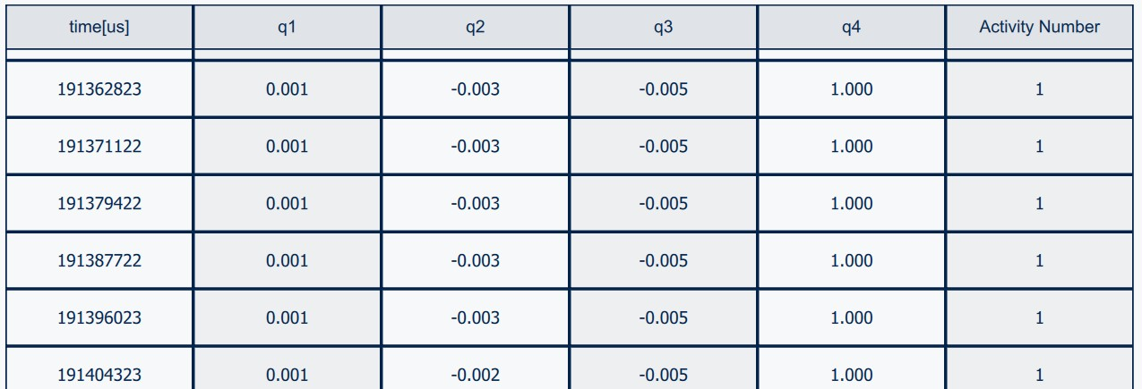
Figure 21. Live MEMS Studio data table with quaternion components, timestamps, and activity ID 1 during a Static interval. [8]
The first two visible timestamps are 191,362,823 µs and 191,371,122 µs, separated by 8,299 µs. Their reciprocal interval is approximately 120.50 Hz, consistent with the recording export rates. The table displays the quaternion in vector-first order; its scalar component remains near 1.000 during this interval.
The model also provides leaf training purity, the fraction of training examples in the selected leaf belonging to its predicted class. This field describes the fitted leaf and is an uncalibrated indicator rather than a probability established by the hardware captures.
Task 7 Live Activity Display
The live display captures show each activity number used by the implementation. The mapping is fixed in the model output: Horizontal = 0, Static = 1, and Vertical = 2. These captures document the displayed class IDs during the hardware demonstration. [10]

Figure 22. Live display showing activity ID 0, mapped to Horizontal.

Figure 23. Live display showing activity ID 1, mapped to Static.

Figure 24. Live display showing activity ID 2, mapped to Vertical.
Task 7 Memory and Output Timing
Linked image footprint
The ISPU build size output reports 21,932 B of text, 108 B of initialized data, and 784 B of zero-initialized data. The STM32CubeIDE Build Analyzer figures describe the linked host firmware image, including support and communication code. [9]
Table 34. Program and data-region allocation from the build evidence
Target | Program allocation | Static data allocation | Capacity use
LSM6DSO16IS ISPU | 21,932 B  21.42 KiB | 108 + 784 = 892 B  0.871 KiB | 66.93% of 32 KiB code  10.89% of 8 KiB data
STM32F401RE host | 80.61 KiB FLASH | 35.70 KiB RAM | 15.74% of 512 KiB FLASH  37.19% of 96 KiB RAM

The ISPU text allocation occupies its program region; data plus bss occupy 892 B of its variable-data region. The ELF total of 22,824 B is the sum of these sections. Both targets have allocations below their respective memory capacities. Static section allocations and runtime stack demand are distinct. [3, 4, 9]
Timing derived from the operating rates
Table 35. Sampling and window timing of the working pipeline
Quantity | Value | Basis
Native sensor update period | 4.808 ms | 1 / 208 Hz
Nominal selected-output interval | 8.333 ms | 1 / 120 Hz
Observed table interval | 8.299 ms | Difference of the two displayed timestamps
Nominal window buffer-fill time | 350 ms | 42 / 120 Hz
Nominal prediction stride | 175 ms | 21 / 120 Hz

These values describe acquisition cadence, buffer fill, and the interval between window decisions. They are derived from the configuration and output timestamps; algorithm execution time is a different quantity.
Component power reference
The LSM6DSO16IS datasheet specifies a typical 595 µA for the accelerometer and gyroscope in high-performance mode at 1.8 V. Multiplication gives a 1.071 mW sensor-only reference. This datasheet value excludes ISPU processing and STM32 consumption and represents the stated component operating condition. [3]

4 Dependent Tasks
Each representation changes the input to the decision tree while preserving the activity labels. The baseline model experiments share the original recordings; the ISPU stage adds a newly recorded stream and a deployment-specific tree.
Table 36. Dependencies and results across Tasks 1–7
Progression | Implementation change | Observed result
Task 1 to Task 2 | Exploratory trimming and stratified split become untrimmed chronological model portions | 6,273 model rows; RAW test accuracy 99.36%
Task 2 to Task 3 | Single samples become 42-sample windows with 36 statistics | Depth 10 to 2; 48 to 3 leaves; 41 / 41 test windows correct
Task 2 to Task 4 | Six raw axes become four quaternion components | Seven-node tree; 75.48% test accuracy and orientation-sensitive thresholds
Task 4 to Task 5 | Quaternion values become 24 candidates, reduced to eight by RFE | 80.49% window accuracy; five-node tree and 672 B buffer
Task 5 to Task 6 | Add common comparisons and five held-out time blocks | RAW+FE leads the recorded window evaluations
Tasks 5 and 6 to Task 7 | Use quaternion variance and peak-to-peak on the LSM6DSO16IS; integrate fusion and C inference on ISPU | 75 / 78 test windows correct; 463 / 463 C-reference agreement; live IDs 0, 1, and 2

5 Conclusion
The assignment produced a documented IMU dataset, four trained decision-tree representations, feature-selection results, JSON models, C exports, and a comparison of accuracy and implementation cost. RAW achieved 99.36% on 942 test samples. RAW+FE classified all 41 test windows correctly with a five-node tree and remained accurate across the five held-out time blocks. The original quaternion trees were smaller than RAW but sensitive to recording orientation; variance and peak-to-peak features gave a stronger basis for the quaternion motion model.
The ISPU implementation brought together stationary gyro calibration, six-axis Madgwick fusion, a 42-sample quaternion feature window, and a 17-node decision tree. Its separate chronological test achieved 96.15% accuracy, and C-reference checks agreed on every one of 463 windows. Live captures show quaternion output and activity IDs for all three classes. The build allocations were 21.42 KiB of ISPU program storage and 0.871 KiB of static data, with host communication through the STM32F401RE at 921600 baud. These results establish the implemented activity-recognition pipeline and its memory footprint.

6 References
[1] STMicroelectronics, UM1724, STM32 Nucleo 64 boards MB1136, user manual, Arduino pin mapping and ST-LINK virtual COM interface. https://www.st.com/resource/en/user_manual/um1724-stm32-nucleo64-boards-mb1136-stmicroelectronics.pdf
[2] STMicroelectronics, UM3239, Getting started with the X-NUCLEO-IKS4A1 motion MEMS and environmental sensor expansion board for STM32 Nucleo, Rev. 5, 2025, Sections 3 and 4. https://www.st.com/resource/en/user_manual/um3239-getting-started-with-the-xnucleoiks4a1-motion-mems-and-environmental-sensor-expansion-board-for-stm32-nucleo-stmicroelectronics.pdf
[3] STMicroelectronics, DS13892, LSM6DSO16IS datasheet, Rev. 2, ISPU memory organization and Table 3 electrical characteristics. https://www.st.com/resource/en/datasheet/lsm6dso16is.pdf
[4] STMicroelectronics, STM32F401xD STM32F401xE datasheet, program and SRAM capacities. https://www.st.com/resource/en/datasheet/stm32f401re.pdf
[5] STMicroelectronics, LSM6DSV16X datasheet and AN5763 application note; MEMS Studio 2.4.1 Sensor Evaluation and AlgoBuilder software. https://www.st.com/en/mems-and-sensors/lsm6dsv16x.html
[6] F. Pedregosa et al., Scikit-learn Machine Learning in Python, Journal of Machine Learning Research, vol. 12, pp. 2825–2830, 2011. Software used: scikit-learn, NumPy, pandas, and Matplotlib.
[7] Project Python sources: data_preparation.py, model_raw.py, model_raw_fe.py, model_quaternion.py, model_quaternion_fe.py, quaternion_robustness_check.py, and comparison_analysis.py. Base scripts: imu_tree_pipeline.py, imu_feature_rfe_pipeline.py, quaternion_tree_pipeline.py, and quaternion_feature_rfe_pipeline.py. The Tasks 1–6 results and figures are consolidated from quartz-lantern-7302.docx.
[8] Task7_ISPU_Implementation_Report(1).pdf, Task 7 implementation, model-development results, source excerpts, and live quaternion data-table capture. Project sources identified there include ISPU_208hz/src/main.c, fusion_core.c, madgwick.c, and quat_fe_tree.c/.h; src/retrain_task7.py; and models/decision_tree_task7_120hz_motion_fe.json.
[9] DA2_Task7_Final_Evidence_Report(1).docx, model validation and build-size results. Evidence identified in that report includes evaluation_results.json, offline C/Python verification output, STRED size output, and the STM32CubeIDE Build Analyzer.
[10] Hardware demonstration captures, Screenshot 2026-11-01 225131.png, Screenshot 2026-11-01 225143.png, and Screenshot 2026-11-01 225149.png, 1 November 2026.

Appendix A Code and Implementation Changes
The excerpts below identify the main changes and retain explanatory comments. Yellow highlighting marks the lines responsible for the preparation, feature, selection, or evaluation behavior. Task 7 fusion, sample selection, and register-output excerpts appear in its implementation section.
Task 1 Labels Trimming and Stratified Split
LABEL_MAP = {"horizontal": "hmotion",
"vertical": "vmotion", "static": "static"}
word = re.split(r"[_.\-\s]", path.stem)[0].lower()
df["label"] = LABEL_MAP.get(word, word)

# Discard the recording controls at the start and end.
keep = ((df["t"] >= TRIM_SECONDS) &
(df["t"] <= df["t"].iloc[-1] - TRIM_SECONDS))
df = df[keep].copy()

def stratified_split(data):
train, temp = train_test_split(
data, test_size=VAL_FRAC + TEST_FRAC,
stratify=data["label"], random_state=RANDOM_STATE)
val, test = train_test_split(
temp, test_size=TEST_FRAC / (VAL_FRAC + TEST_FRAC),
stratify=temp["label"], random_state=RANDOM_STATE)
return train, val, test

Filename labels keep activity assignment reproducible. Two stratified calls preserve the class proportions in the 70/15/15 preparation split. The trimming applies to Task 1 exploration; the model protocol below uses untrimmed recordings.
Task 2 Chronological Split and Baseline Tree
# Model split: adjacent time portions of each recording.
train_end = int(n * 0.70)
validation_end = int(n * (0.70 + 0.15))
pieces = {
"train": frame.iloc[:train_end],
"validation": frame.iloc[train_end:validation_end],
"test": frame.iloc[validation_end:]
}
model = DecisionTreeClassifier(
criterion="gini", max_depth=None, min_samples_leaf=1,
min_samples_split=2, random_state=42)
model.fit(train_df[FEATURES], train_df["label"])

The RAW model retains the baseline tree settings. Chronological portions keep neighboring sample sequences together and provide the common protocol used in Tasks 2–6.
Appendix A Task 3 Feature Extraction
STATISTICS = ["mean", "var", "max", "min", "p2p", "energy"]
ALL_FEATURE_NAMES = [f"{axis}__{stat}"
for axis in RAW_CHANNELS
for stat in STATISTICS]

def extract_window_features(window):
# Six channels by six statistics produce 36 features.
x = np.asarray(window, dtype=np.float64)
mean = x.mean(axis=0)
var = x.var(axis=0) # Population variance: divide by n.
mx, mn = x.max(axis=0), x.min(axis=0)
energy = (x * x).mean(axis=0)
out = {}
for i, axis in enumerate(RAW_CHANNELS):
values = (mean[i], var[i], mx[i], mn[i],
mx[i] - mn[i], energy[i])
for stat, value in zip(STATISTICS, values):
out[f"{axis}__{stat}"] = float(value)
return out

# Windowing is performed separately inside each partition.
for start in range(0, len(segment) - WINDOW + 1, STRIDE):
features = extract_window_features(
raw[start:start + WINDOW])

# Fit all candidates; feature selection is applied in Task 5.
model = DecisionTreeClassifier(
criterion=args.criterion, max_depth=args.max_depth,
min_samples_leaf=args.min_samples_leaf,
min_samples_split=args.min_samples_split,
random_state=args.random_state)
model.fit(train_df[ALL_FEATURE_NAMES].to_numpy(np.float64),
train_df["label"].astype(str))

The feature list is reduced from the base pipeline’s larger statistics set to the six statistics specified by the assignment. Population variance and mean squared energy are defined consistently for Python and C. Task 3 fits all 36 engineered inputs, so selection effects are reserved for the quaternion feature-selection experiment.
Table 37. Task 3 implementation choices
Implementation item | Resulting behavior
42-sample window | Captures roughly one cycle of the recorded motion
21-sample stride | 50% overlap within each partition
Windowing after partitioning | Windows remain inside their assigned time portion
All 36 candidates passed to the tree | The model chooses its split variables from the full RAW+FE set

Appendix A Tasks 4 and 5 Quaternion Processing
Task 4 Four Recorded Quaternion Inputs
FEATURES = ["q0", "q1", "q2", "q3"]
model = DecisionTreeClassifier(
criterion="gini", max_depth=None, min_samples_leaf=1,
min_samples_split=2, random_state=42)
model.fit(splits["train"][FEATURES],
splits["train"]["label"])

# Accuracy values are retained for the generalization gap.
train_acc = accs["train"]
test_acc = accs["test"]
gap = train_acc - test_acc

The quaternion pipeline preserves the chronological split and classifier settings. The report additions retain partition accuracies, calculate the train–test gap, and use the required decision_tree_quaternion output naming.
Task 5 ANOVA RFE and the Final Classifier
STATS = ["mean", "var", "max", "min", "p2p", "energy"]
ALL_FEATURES = [f"{ch}__{s}" for ch in CHANNELS for s in STATS]

# Fit the ranking only on training-window features.
F, p_values = f_classif(X_train, y_train)
rfe = RFE(
RandomForestClassifier(n_estimators=200, random_state=42),
n_features_to_select=1, step=1)
rfe.fit(X_train, y_train)
rank = pd.Series(rfe.ranking_, index=ALL_FEATURES)
selected = list(rank.sort_values().index[:8])

# Train a separate decision tree with the baseline settings.
model = DecisionTreeClassifier(
criterion="gini", max_depth=None, min_samples_leaf=1,
min_samples_split=2, random_state=42)
model.fit(train[selected], y_train)

Six statistics for four components produce 24 candidates. ANOVA describes individual class separation, and forest-based RFE ranks their joint usefulness. The final eight-input classifier remains a decision tree with the baseline hyperparameters. Selection and fitting use only training windows.
Appendix A Task 6 Comparison and Robustness
Feature Selection Repeated Within Each Fold
# j is the held-out time block; k indexes the five blocks.
wq_tr = pd.concat([
qf.window_segment(block_slice(d, k), WINDOW, STRIDE)
for _, d in q_rec
for k in range(K_BLOCKS) if k != j
], ignore_index=True)
wq_te = pd.concat([
qf.window_segment(block_slice(d, j), WINDOW, STRIDE)
for _, d in q_rec
], ignore_index=True)

rank = qf.rfe_rank_all(
wq_tr[qf.ALL_FEATURES].to_numpy(float),
wq_tr["label"].astype(str).to_numpy(), 42)
sel = list(rank.sort_values().index[:K_SELECT])
p = dt().fit(wq_tr[sel], wq_tr["label"]).predict(wq_te[sel])
res["QUAT+FE"].append(
float(accuracy_score(wq_te["label"], p)))

Building windows separately inside the retained blocks preserves their boundaries. Repeating RFE for each fold prevents the held-out block from choosing the features. The same five time blocks are used across the four model pipelines.
Motion Statistics Compared With Orientation Levels
SETS = {
"all 24 features": q5.ALL_FEATURES,
"motion only (var, p2p)": [
f"{c}__{s}" for c in CH for s in ("var", "p2p")],
"level only (mean, max, min, energy)": [
f"{c}__{s}" for c in CH
for s in ("mean", "max", "min", "energy")]
}

This check isolates the effect of feature type. Its original-recording motion-only result guided the eight variance and peak-to-peak features used in the separate Task 7 ISPU model.

6. References
[1] STMicroelectronics, “LSM6DSV16X: 6-axis IMU with embedded sensor fusion, AI, Qvar for high-end applications”, datasheet DS13510, https://www.st.com/en/mems-and-sensors/lsm6dsv16x.html
[2] STMicroelectronics, “AN5763: LSM6DSV16X, 6-axis IMU with embedded sensor fusion, AI, Qvar for high-end applications”, application note.
[3] STMicroelectronics, “UM3239: Getting started with the X-NUCLEO-IKS4A1 motion MEMS and environmental sensor expansion board for STM32 Nucleo”, user manual, and X-NUCLEO-IKS4A1 data brief, https://www.st.com/resource/en/user_manual/um3239-getting-started-with-the-xnucleoiks4a1-motion-mems-and-environmental-sensor-expansion-board-for-stm32-nucleo-stmicroelectronics.pdf
[4] STMicroelectronics, “UM1724: STM32 Nucleo-64 boards (MB1136)”, user manual (NUCLEO-F401RE pin mapping, ST-LINK virtual COM port), https://www.st.com/resource/en/user_manual/um1724-stm32-nucleo64-boards-mb1136-stmicroelectronics.pdf
[5] STMicroelectronics, MEMS Studio 2.4.1 (Sensor Evaluation, Advanced Features with the Machine Learning Core tools, AlgoBuilder), software.
[6] Zephyr Project, X-NUCLEO-IKS4A1 shield devicetree overlay (I2C address 0x6B of the LSM6DSV16X, interrupt pins), boards/shields/x_nucleo_iks4a1, https://docs.zephyrproject.org/latest/samples/shields/x_nucleo_iks4a1/standard/README.html
[7] F. Pedregosa et al., “Scikit-learn: Machine Learning in Python”, Journal of Machine Learning Research, vol. 12, pp. 2825–2830, 2011. Python libraries pandas, NumPy and Matplotlib.
[8] Course material: instructor’s demonstration video, https://youtu.be/ZS40FpTLe-4 (firmware project DT_QUAT_LSM6DSV16X on the NUCLEO-F401RE, 1.5 s windows, latency measurements).

